Calibration and similarity of centrifugal pump

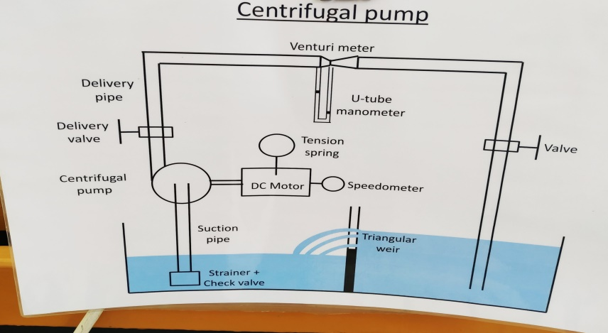Objective

To study the performance of the centrifugal pump for different flow rates at different speed, draw the pump characteristic curves and Verify using of similarity rules on this pump.

Procedure

1. Operate the pump at certain speed (2000 RPM)
2. Start open the valve at delivery side till its maximum opening
3. Change the current supplied to the motor till we have the pump running at (2000 RPM)
4. Take the needed readings for that case and start fill the table

* Manometric suction head (Hms) by using pressure gauge on suction side (ft.)
* Manometric delivery head (Hmd) by using pressure gauge on delivery side (ft.)
* U-tube manometer Reading (y) in (cm)
* 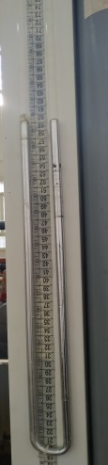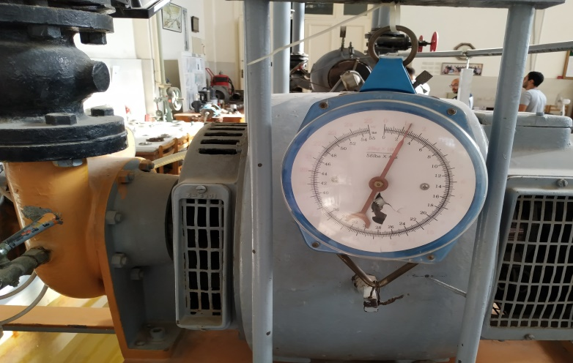Force (F) that balance the stator by using spring mass balance (kg.f)

1. 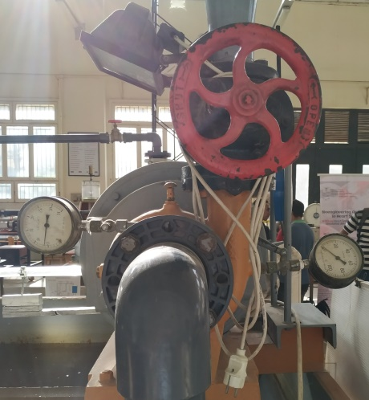Start to change the valve opening and repeat step 3,4
2. Change the speed on the pump to be (2500 RPM)
3. Repeat from step 2 till step 5 for this speed

Reading at case 1 (N=2000 RPM)

|  |  |  |  |
| --- | --- | --- | --- |
| Y (cm) | Hms (ft) | Hmd (ft) | F (kg.f) |
| 17 | 9 | 20 | 5 |
| 13 | 6 | 32 | 4.2 |
| 6 | 3 | 45 | 3.2 |
| 0 | 0 | 60 | 0.5 |

Reading at case 1 (N=2500 RPM)

|  |  |  |  |
| --- | --- | --- | --- |
| Y (cm) | Hms (ft) | Hmd (ft) | F (kg.f) |
| 27 | 13 | 26 | 8.4 |
| 18 | 8 | 52 | 7.9 |
| 7.5 | 4 | 72 | 6.5 |
| 0 | 0 | 82 | 2.2 |

Equations

1. Pump Manometric head:

Hm = Hmd - Hms

1 ft = 0.3048 meter

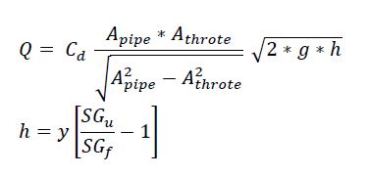 2) Flow Rate:

Where:

Cd = 0.94

dpipe = 10 cm (Apipe = Pi/400 m2)

dthroat = 6.86 cm (Athroat = 3.696/1000 m2)

y = U-tube manometer reading

SGu = 13.6

SGf = 1

Final Form for Q = (61.877/1000) * (y)0.5

1. Efficiency

η = (O/P) / (I/P)

Where:

O/P = Denistywater x Hm x Q

I/P = T x ω

T = F x R

ω = 2π N / 60

R (brake radius) = 0.3048 m.

Final Form for I/P = (10.16 * pi/1000 ) * N * F

Final form for O/P = 1000 x Hm x Q

Practical calculations at case 1 (N=2000 RPM)

|  |  |  |  |  |
| --- | --- | --- | --- | --- |
| Hm (m) * 0.3048 | Q (m3/s) *10(-3) | O/P (W) | I/P {Shaft Power} (W) | Efficiency |
| 11 | 25.51 | 85.53 | 319.2 | 26.8% |
| 26 | 22.31 | 176.8 | 268.1 | 65.94% |
| 42 | 15.156 | 194 | 204.3 | 94.95% |
| 60 | 0 | 0 | 32 | 0% |

Practical calculations at case 2 (N=2500 RPM)

|  |  |  |  |  |
| --- | --- | --- | --- | --- |
| Hm (m) * 0.3048 | Q (m3/s) *10(-3) | O/P (W) | I/P {Shaft Power} (W) | Efficiency |
| 13 | 32.15 | 127.4 | 670.3 | 19% |
| 44 | 26.25 | 352 | 630.4 | 55.83% |
| 68 | 16.94 | 351.1 | 518.676 | 67.7% |
| 82 | 0 | 0 | 175.5 | 0% |

Theoretical calculations at case 2 (N=2500) using similarity rules at case 1 readings.

Q2/Q1 = N2/N1

H2/H1 = (N2/N1)2

Psh2/Psh1 = (N2/N1)3

|  |  |  |  |  |
| --- | --- | --- | --- | --- |
| Hm (m) * 0.3048 | Q (m3/s) *10(-3) | O/P (W) | I/P {Shaft Power} (W) | Efficiency |
| 17.19 | 31.8875 | 167.1 | 623.4 | 26.8% |
| 40.625 | 27.8875 | 345.3 | 523.6 | 66% |
| 65.625 | 18.945 | 379 | 399 | 94.98% |
| 93.75 | 0 | 0 | 62.5 | 0% |

Comment

After Studying the graphs we could deduce that: As the rotational speed of the pump increase the flow rate (Q) increases as well as the Head (Hm) provided at this flow rate, the shaft power also increases with the speed increases and efficiency varies as in practical case it decreases.

But for theoretical case which we get using the similarity rules we could say that as the rotational speed of pump increases we got increase in provided head, flow rate, Shaft power but here affinity rule take place and each flow rate has the same efficiency for its opposite flow rate at the other speed so we had that shifted efficiency at the theoretical case.  
the error exists in the second case between the theoretical and practical results due to having some reading errors in measuring instruments and variations in supplied current as load changes leading to further errors.